NAME: _____________ | Statistics and Probability
Simulations Practice | DATE: Thursday, June 15, 2017
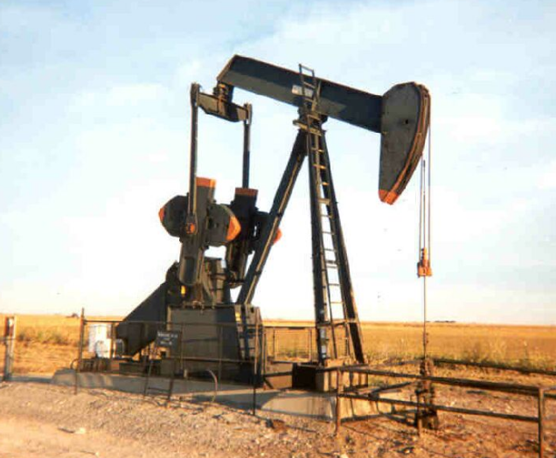
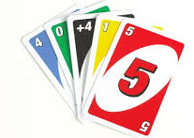
- At Uno, when someone plays a color that you don’t have, you have to keep drawing until you get one. Each time, you have ¼ chance of getting the right color (lets assume the deck is really, really large, so each time, the odds stay the same). How many cards do you expect it will take until you get that color you need.
Conduct a simulation with 20 trials. Write your results from your trials below.

Using your simulation:
  - What is the expected number of cards that you will need to pick up until you have one to play?

  - What is the probability that it will take more than 5 cards?

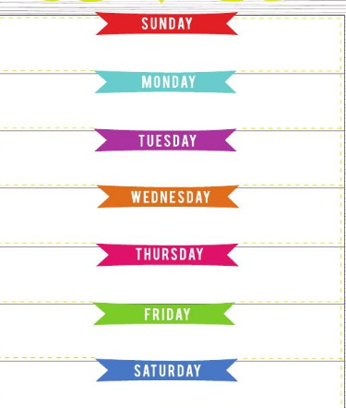
- We are playing a guessing game, where you will win$5 if you guess what day of the week I was born. Each guess costs $2. You play until you guess correctly. So you start off, guessing Saturday. It wasn’t Saturday, so you guess again. Y ou guess Tuesday, it wasn’t Tuesday, you guess again. This time you say Wendesday and you win – I was born on a Wednesday. On average, how many guesses will you need to make?
Conduct a simulation with 20 trials. Write your results from your trials below.

Using your simulation:
  - What is the expected number of guesses you will need to make?

  - You only win money than you lose if you get it on 2 or fewer times, how often will that happen?
- 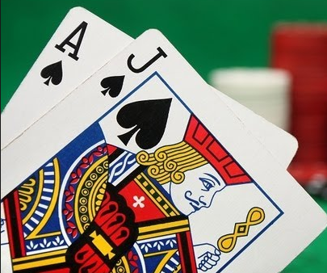If you have a 45% chance of winning at blackjack, and you play 10 hands. How many are you likely to win.
Conduct a simulation with 20 trials. Write your results from your trials below.

Using your simulation:
  - What is the expected number of times you will win?

  - You need to win 6 or more times to win money, what percent of the time did that happen?

- 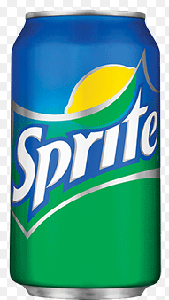Sprite has a contest where 1 in 6 bottles wins. You are going to buy bottles until you win. How many bottles on average will it take to get a winner.
Conduct a simulation with 20 trials. Write your results from your trials below.

Using your simulation:
  - How many bottles on average will it take to get a winner?

  - What is the probability that you will only need to buy 2 bottles or less?

